Computer Language Coding Concepts

Variable Amount in a Diagram
The array parameter, that represents the variable amount of arguments, does not have a special display in the diagram (yet). What is important to remember about the concept of variable amount of arguments is that: parameters can be arrays.

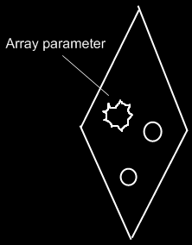

See also: Variable Amount

Author & Copyright: Jan-Joost van Zon Date: September 30, 2008 – September 30, 2008 Location: Oosterhout, The Netherlands Status: Finished

